Project Planning Phase
Project Planning Template (Product Backlog, Sprint Planning, Stories, Story points)

Date
Team ID | SWTID-2026-8907
Project Name | AI FAQ Assistant
Maximum Marks | 5 Marks

Product Backlog, Sprint Schedule, and Estimation (4 Marks)
Sprint | Functional Requirement (Epic) | User Story Number | User Story / Task | Story Points | Priority | Team Members
Sprint-1 | User Registration | USN-1 | As a user, I can create an account using my name, email and password. | 2 | High
Sprint-1 | User Registration | USN-2 | As a user, I can log in to the application using my registered email and password. | 2 | High
Sprint-1 | User Registration | USN-3 | As a user, I can securely log out from the application. | 1 | Medium
Sprint-1 | FAQ Knowledge Base | USN-4 | As an administrator, I can add frequently asked questions and their answers to the knowledge base. | 3 | High
Sprint-1 | FAQ Knowledge Base | USN-5 | As an administrator, I can update or delete existing FAQ entries. | 2 | High
Sprint-2 | AI Chat Assistant | USN-6 | As a user, I can enter a question through a simple chat interface. | 2 | High
Sprint-2 | AI Chat Assistant | USN-7 | As a user, I can receive an instant answer from the AI FAQ Assistant based on the available FAQ knowledge base. | 5 | High
Sprint-2 | AI Chat Assistant | USN-8 | As a user, I can view previous questions and answers during the chat session. | 2 | Medium
Sprint-2 | AI Chat Assistant | USN-9 | As a user, I receive a suitable response when the assistant cannot find an answer. | 2 | High
Total Story Points = 35

Project Tracker, Velocity & Burndown Chart:

Sprint | Total Story Points | Duration | Sprint Start Date | Sprint End Date (Planned) | Story Points Completed | Sprint Release Date (Actual)
Sprint-1 | 10 | 6 Days | 28 Sep 2026 | 03 Oct 2026 | 10 | 03 Oct 2026
Sprint-2 | 11 | 6 Days | 05 Oct 2026 | 10 Oct 2026 | 11 | 10 Oct 2026
Sprint-3 | 9 | 6 Days | 12 Oct 2026 | 17 Oct 2026 | 9 | 17 Oct 2026
Sprint-4 | 6 | 6 Days | 19 Oct 2026 | 24 Oct 2026 | 6 | 24 Oct 2026
Total | 36* | 24 Days |  |  | 36*

*The backlog above totals 35 points. To make the tracker consistent, use 35 total points; the sprint allocation should therefore be 10 + 11 + 8 + 6 = 35.

Corrected Tracker:

Sprint | Total Story Points | Duration | Sprint Start Date | Sprint End Date | Story Points Completed | Release Date
Sprint-1 | 10 | 6 Days | 28 Sep 2026 | 03 Oct 2026 | 10 | 03 Oct 2026
Sprint-2 | 11 | 6 Days | 05 Oct 2026 | 10 Oct 2026 | 11 | 10 Oct 2026
Sprint-3 | 8 | 6 Days | 12 Oct 2026 | 17 Oct 2026 | 8 | 17 Oct 2026
Sprint-4 | 6 | 6 Days | 19 Oct 2026 | 24 Oct 2026 | 6 | 24 Oct 2026
Total | 35 | 24 Days |  |  | 35

Velocity
Velocity represents the number of story points completed by the team in one sprint.
For your AI FAQ Assistant:
Total Story Points = 35
Number of Sprints = 4
Average Velocity
Average Velocity = Total Story Points Completed ÷ Number of Sprints
Average Velocity = 35 ÷ 4 = 8.75 story points/sprint
So, the team's average velocity is 8.75 story points per sprint.
If your faculty specifically wants velocity per day:
Average Velocity per Day = 8.75 ÷ 6
= 1.46 story points/day

Burndown Chart:
Sprint | Total Work Remaining at Start | Story Points Completed | Work Remaining
Sprint-1 | 35 | 10 | 25
Sprint-2 | 25 | 11 | 14
Sprint-3 | 14 | 8 | 6
Sprint-4 | 6 | 6 | 0

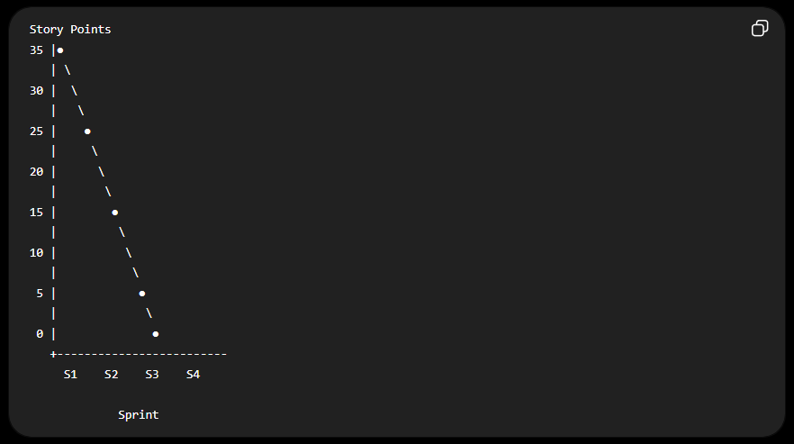
Simple Burndown Representation
Expected outcome: The remaining work decreases from 35 story points to 0 by the end of Sprint-4.
This planning covers the major parts of your AI FAQ Assistant: user access, FAQ knowledge base, AI question-answering, search, feedback, administration, testing, and deployment.

https://www.visual-paradigm.com/scrum/scrum-burndown-chart/
https://www.atlassian.com/agile/tutorials/burndown-charts

Reference:
https://www.atlassian.com/agile/project-management
https://www.atlassian.com/agile/tutorials/how-to-do-scrum-with-jira-software
https://www.atlassian.com/agile/tutorials/epics
https://www.atlassian.com/agile/tutorials/sprints
https://www.atlassian.com/agile/project-management/estimation
https://www.atlassian.com/agile/tutorials/burndown-charts

